Issued: January 19th, 2011
Conduct: Teams of 2
Requirements: (1) Laptop computers with Internet access and a web browser
BACKGROUND
This Case Study expands your knowledge of certification requirements to an important safety system that has saved many lives: the Enhanced Ground Proximity Warning System (EGPWS). The objective is to locate the regulatory requirements for EGPWS and to understand the Intended Function of each of the EGPWS modes.
SCENARIO
Your loyal customer is back again after his successful implementation of the ADC architecture for the Piaggio Avanti. (Case 3), and he has learned that there might be a huge market for the Enhanced Ground Proximity Warning System that he plans to develop (Figure 1). Before doing so: (1) He wants to understand the marketplace, so he needs to know the regulatory obligation to install EGPWS for different sizes of aircraft; 2) He doesn’t really understand what an EGPWS is supposed to accomplish, other than helping to prevent Controlled Flight Into Terrain (CFIT) accidents; 3) He doesn’t understand the interaction between the EGPWS and the Multifunction Display (MFD), if one is installed. He has asked you to help him address these questions.
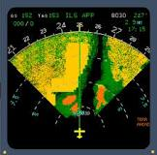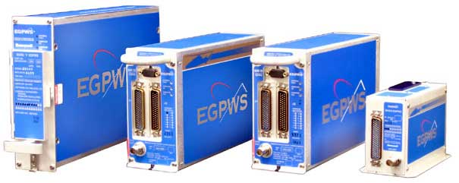
http://tinyurl.com/3swg5bw http://tinyurl.com/4y9m2ts
Figure 1 – EGPWS Display and Units

Some definitions

CFIT: Controlled Flight Into Terrain
CFIT describes an accident in which an airworthy aircraft, under pilot control, is unintentionally flown into the ground, a mountain, water, or an obstacle (http://tinyurl.com/3j89pbk). Numerous CFIT accidents led to the development, and eventual mandating, of GPWS, EGPWS, and TAWS.

GPWS Ground Proximity Warning System
The original terrain warning systems were introduced in the 70’s as a result of several high-profile CFIT accidents. GPWS relied on radio altitude and radio altitude rate information to provide warnings of dangerous terrain closure. The system suffered from excessive false alarms, and had no “look-ahead” capability, but still reduced CFIT accidents measurably. The system is now often referred to as “Basic GPWS” and has largely been superseded by TAWS. Basic GPWS is no longer mandated in North America or Europe.

EGPWS Enhanced Ground Proximity Warning System
The trademark for the system introduced by Honeywell in 1991 to overcome the look-ahead limitation. EGPWS uses a 3-D terrain map to look ahead of the aircraft and provide meaningful predictive warnings. This ability allowed the introduction of a number of new warning modes. CFIT accidents with EGPWS equipped aircraft have dropped off to almost zero since the introduction of TAWS.

TAWS Terrain Awareness and Warning Systems (TAWS)
TAWS is a collective term used by the FAA to encompass Honeywell’s EGPWS and similar systems made by other manufacturers. Confusingly, ICAO uses the term GPWS to refer to TAWS systems, not to “basic” GPWS systems.
TASKS
Using the references that were distributed following Assignment 1, answer the following questions:
- Based on the CARs and advisory materials, when is an EGPWS is required?
For Canadian registered aircraft, CAR 605.37 (Ground Proximity Warning System) states:
(1) Subject to subsections (2) and (3), no person operating under Subpart 4 or 5 of Part VII shall conduct a take-off in a turbo-jet-powered aeroplane that has a MCTOW of more than 15,000 kg (33,069 pounds) and for which a type certificate has been issued authorizing the transport of 10 or more passengers, unless the aeroplane is equipped with a ground proximity warning system.
(2) An aeroplane referred to in subsection (1) may be operated without a serviceable ground proximity warning system if a minimum equipment list has been approved by the Minister in respect of the operator of the aeroplane pursuant to subsection 605.07(3) and the aeroplane is operated in accordance with the minimum equipment list.
(3) Where, in the interests of aviation safety, it is necessary during a flight to deactivate any mode of a ground proximity warning system, the pilot-in-command of the aeroplane may deactivate that mode if the deactivation is performed in accordance with the aircraft flight manual, aircraft operating manual, flight manual supplement or minimum equipment list.
This section of the CARs, which mandates EGPWS, is interesting because it is not under Part 5 (Airworthiness) but Subpart 5 (Aircraft Requirements) of Part 6 (General Operating and Flight Rules). This same Subpart also mandates other important safety equipment, which we would expect to find under airworthiness, such as:
- Safety Belts – 605.22
- Flight Data Recorder and Cockpit Voice Recorder – 605.33
- Altitude Alerting Systems – 605.36
- Emergency Locator Transmitters (ELT) – 605.38
- Third (standby / emergency) Attitude Indicator – 605.41
For comparison, the TAWS mandates from the FAA and ICAO are shown in Table 1 and Table 2 below.

FAR | Applicable to | Requirement
91.223 | General Operating And Flight Rules  (i.e. most aircraft operations) | a) Airplanes manufactured after March 29, 2002. Except as provided in paragraph (d) of this section, no person may operate a turbine-powered U.S.-registered airplane configured with six or more passenger seats, excluding any pilot seat, unless that airplane is equipped with an approved terrain awareness and warning system that as a minimum meets the requirements for Class B equipment in Technical Standard Order (TSO)-C151.
135.154 | Charter & Commuter operations | (a) Airplanes manufactured after March 29, 2002:  (1) No person may operate a turbine-powered airplane configured with 10 or more passenger seats, excluding any pilot seat, unless that airplane is equipped with an approved terrain awareness and warning system that meets the requirements for Class A equipment in Technical Standard Order (TSO)-C151. The airplane must also include an approved terrain situational awareness display.  (2) No person may operate a turbine-powered airplane configured with 6 to 9 passenger seats, excluding any pilot seat, unless that airplane is equipped with an approved terrain awareness and warning system that meets as a minimum the requirements for Class B equipment in Technical Standard Order (TSO)-C151.
121.354 | Scheduled airline operations | (a) Airplanes manufactured after March 29, 2002. No person may operate a turbine-powered airplane unless that airplane is equipped with an approved terrain awareness and warning system that meets the requirements for Class A equipment in Technical Standard Order (TSO)-C151. The airplane must also include an approved terrain situational awareness display.

Table 1 - FAA TAWS Requirements
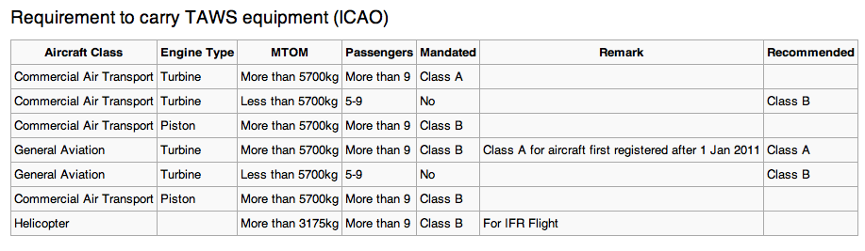
Table 2 - ICAO TAWS Requirements

- When must the EGPWS display information on the MFD?

TSO-C151b Section 3.5 (Class A Equipment Requirements for a Terrain Display):
Class A equipment must be designed to interface with a Terrain Display, either color or monochromatic. Class A equipment for TAWS must be capable of providing the following terrain related information to a display system:

- The terrain must be depicted relative to the airplane’s position such that the pilot may estimate the relative bearing to the terrain of interest.
- The terrain must be depicted relative to the airplane’s position such that the pilot may estimate the distance to the terrain of interest.
- The terrain depicted must be oriented to either the heading or track of the airplane. In addition, a North-up orientation may be added as a selectable format.
- Variations in terrain elevation depicted relative to the airplane’s elevation (above and below) must be visually distinct. Terrain that is more than 2000 feet below the airplane’s elevation need not be depicted.
- Terrain that generates alerts must be displayed in a manner to distinguish it from non-hazardous terrain, consistent with the caution and warning alert level.

TSO-C151b Section 3.6 (Class B Equipment Requirements for a Terrain Display):
Operators required to install Class B equipment are not required to include a Terrain Display. However, Class B TAWS equipment must be capable of driving a terrain display function in the event the installer wants to include the terrain display function. NOTE: This TSO does not include requirements for the display system/hardware.
- What is this kind of EGPWS called?
An EGPWS or TAWS with a required terrain display is called a Class A TAWS. Class A systems also have several added requirements over a Class B system, including a number of additional operating modes, as shown in the second column of Table 3 below.

There is an additional Class C TAWS classification that is intended for voluntary installations on small General Aviation (GA) aircraft not covered by the FAA TAWS requirements. Class C TAWS equipment must meet all the requirements of a Class B TAWS with a number of “small aircraft” modifications described in Appendix 4 of TSO-c151b. Class C TAWS systems must be marked so that they can be uniquely distinguished from the Class A and B TAWS required by 14 CFR parts 91, 135, and 121.

- What does an EGPWS “Flap Override” do?
The Flap Override is a guarded switch that allows the pilot to inhibit the Mode 4 (Landing Configuration) alerts and warnings in the event that the aircraft is being landed with the flaps intentionally not in the landing position. This eliminates false alarms in this scenario.
- Complete Table 3 below:

TAWS  MODE | TAWS  CLASS | CONDITION | “SOFT” WARNING AMBER MSG +  AURAL ALERT  Examples: | “HARD” WARNING  RED MSG +  AURAL WARNING  Examples:
1 | A & B | Excessive descent rate | “SINK RATE!” | “PULL UP!”
2 | A & B | Excessive terrain closure rate | “TERRAIN, TERRAIN!” | “PULL UP!”
3 | A & B | Excessive altitude loss after take off or go-around | “DON’T SINK!” | –
4a | A Only | Unsafe terrain clearance while gear not locked down | “TOO LOW-GEAR!” | “TOO LOW-TERRAIN!”
4b | A Only | Unsafe terrain clearance while landing flap not selected  (May be inhibited by the pilot via a guarded switch) | “TOO LOW-FLAP!” | “TOO LOW-TERRAIN!”
4c | A Only | Terrain rising faster than aircraft after take off | “TERRAIN!" | –
5 | A Only | Excessive descent below ILS glideslope | “GLIDESLOPE!” | “GLIDESLOPE!”
6 | A & B | Radio Height Advisory Callout | “FIVE HUNDRED”  (no light) | –
6 | A & B | Bank Angle Advisory Callout | “BANK ANGLE!”  (no light) | –
7 | A & B | Windshear Protection (new) | “WINDSHEAR” | –
– | A & B | Terrain Proximity | “CAUTION TERRAIN!” | “TERRAIN! TERRAIN!  PULL UP!”

Table 3 – Basic EGPWS Modes and Callout Examples

These subparts refer to operations under CAR 704 (Commuter) and 705 (Airline) respectively. The approximate FAR equivalents are Parts 135 and 121 respectively.
http://tinyurl.com/6ak46rm
See also DO-161A, “Minimum Performance Standards for Airborne Ground Proximity Warning Equipment,” May 27, 1976.

